**First person movement mechanic**

This is inspired and meant to be similar to how the player moves in in the game doom.

The code is to be used for first person games. Like first person shooters and it is meant to be basic.

To start making the mechanic first we need to decide what will be the player. For this tutorial, I will be using the main camera which is automatically created on the scene. First create a c# script file and attach it to the main camera.

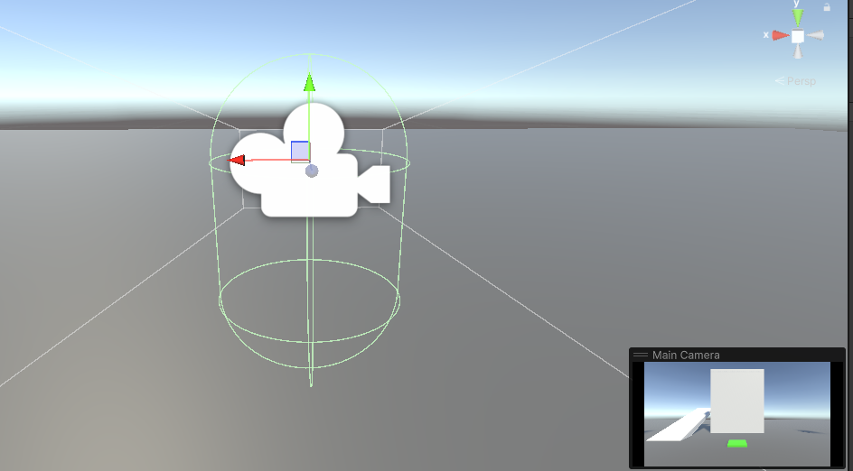

Once you have opened the script file the first thing, we will add will be a float variable. You can call all the variables anything you want as long as you understand what they are used for. This variable will be used to as the speed of the player. The float is public so in inspection you can alter the value as seen in the image under.

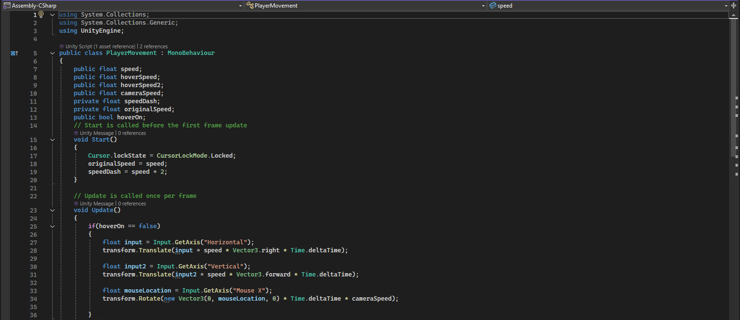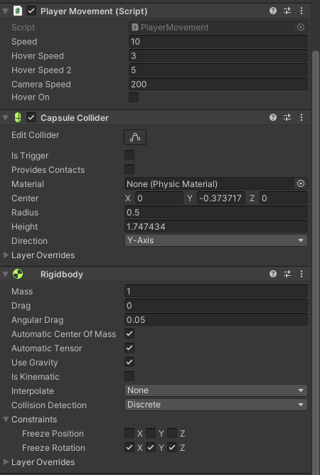

After making the variable on the update function write the code in the picture below, which checks if either the A or D keys are pressed as in unity they should be assigned as horizontal keys.



Once the first line of code is written then write the second line as seen in the image above. This line is what moves the player horizontally. The input float is used just to tell if you are moving or not, the float that we created is used as how fast the player is moving and finally the “Time.deltaTime” is used since by default unity will be running with big amount of frames so this piece is used to have the player mover correctly as if it was 60 fps.

Once done with that part of the code we can now write the next two lines. Although it is also easier to duplicate the first two lines as it is like the first two but with some minor changes. These changes are calling the input float a different name, changing from horizontal to vertical and in the “Vector3” part changing from saying right to forward. All of this will do is when pressing W or S the player will move forwards or backwards.



Once you are done with the player movement code, we can now work on the camera movement. The camera will only be able to move in the x axis.

Now where the first float was written add another float variable. This float will be used for the speed of the camera.

Before writing the main code in the update function in the start function add the line as seen in the image. This will lock the mouse to the center of the game screen and not be visible.



After that for code its similar to the movement code but the only difference being that instead of using “Translate” it is “Rotate”, in the red name it says Mouse X to indicate that it is using the x axis. This can be seen in the image below.



Finally, after finishing both the player movement and the camera movement there is one more part of the script left. This part is not needed but it works with this code so that is why I added it, and because in the doom game you can run/dash.

Now back to the where all the variables are, add two private float variables. These two are important for this to work.



Once you have written the variable on the start function add two quick lines of code as seen in the image. The first one is going to be used to revert the speed value after the player dashes. And the second one I to calculate how much the speed will be increased.



Then go to the update function and add two if statements which check if the key is being pressed or being let go. In both statements the code has the speed changing to the other two float variables.

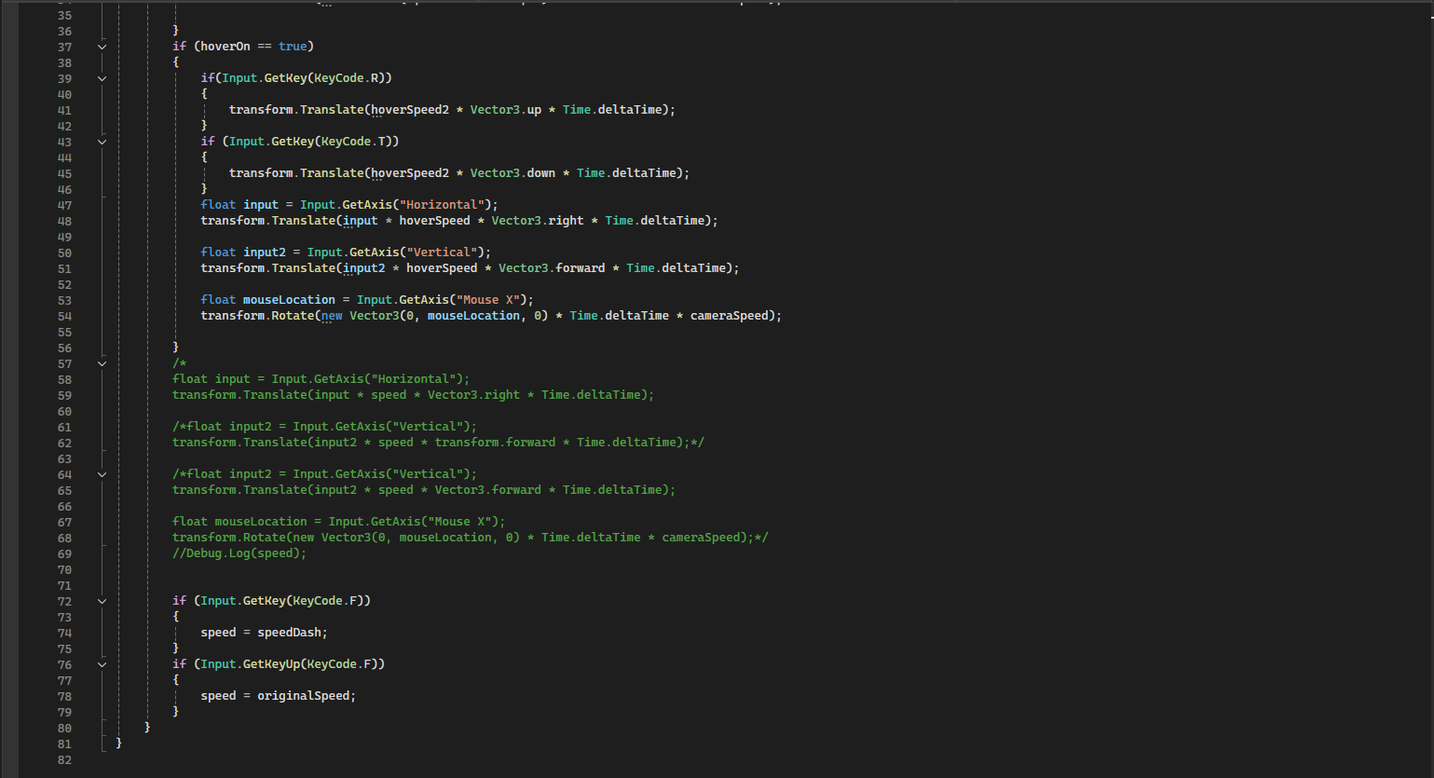

Once all the code is done, it can be saved and tested in case of errors.

References:

<https://discussions.unity.com/t/how-to-rotate-the-camera-up-and-down-using-mouse-input/239201>

<https://github.com/LSBUGPG/movement-tutorial?tab=readme-ov-file>